Assignment 1: MovieStarInfo
Due: Tues, January 9, 2013, 9:00 PM

In this assignment, you will display information about your favorite actor and your favorite actress.

- The first thing that you should do is create a new project. Name it YourNameMovieStar

MovieStarInfo
Print out information on my favorite actor or actress.
Name
Gender
Age
Birthday
Best Appearance
Short Biography
END

- Create a form as shown on Page 2, Double-click the “Go” button and place your code inside the Go Subroutine
- Add a List Box and name it lstActor, add a RichTextBox and name it: rtbBio, add an Exit button

- Declare and initialize the following variables. You should choose appropriate data types for each piece of information. You should initialize each variable to information about your chosen actor or actress.

strActorName
strActorGender
intActorAge
strActorBday
strActorBest
strActorBio
strActressName
strActressGender
intActressAge
strActressBday
strActressBest
strActressBio

For example: Dim strActorName as String = “Bill Pullman”

- Display the name, gender, age, birthday and best film data in a List Box named lstActor:

For example: lstActor.Items.Add(“Favorite Actor: “ & strActorName)

- Display the biographical paragraph in a RichTextBox named rtbBio
For example rtbBio.text = strActorBio

You may get information about your actor/actress from the internet. A good source is http://www.imdb.com

Turning in the project: Name: YourNameMovieStar

Zip the entire project and upload the zipped file to Blackboard Assignment1

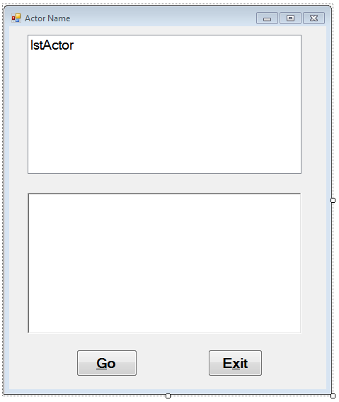

Object: lstActor
Here’s some information on my favorite actor and actress:

Favorite Actor: Bill Pullman
Gender: M
Age: 51
Birthday: December 17, 1953
Best Appearance: While you were Sleeping

Object: rtbBio
Short Biography: Born in Hornell, New York, Bill is one of seven children. He attended the State University of New York at Delhi and University of Massachusetts at Amherst. He worked with various theater companies, most notably the Folger Theater Groupe and the Los Angeles Theater Center. He made his big screen debut in the Danny DeVito - Bette Midler comedy "Ruthless People" in 1986 and followed that

